ONLINE FASHION STORE MANAGEMENT SYSTEM
-DATABASE MANAGEMENT SYSTEMS PROJECT-

GROUP MEMBERS-
1. AS2022610 - D. C. A. Gamage
2. AS2022482 - D. L. B. Wijesekara
3. AS2022525 - D. L. A. Thathsarani
4. AS2022587 - N. D. K. N. Sooriyasena
5. AS2022383 - H. G. G. De Zoysa
6. AS2022584 - N. A. S. Perera

Contents
ONLINE FASHION STORE MANAGEMENT SYSTEM 1
NEED OF A SOLUTION 3
Problems Currently Facing 3
How an optimized database helps 4
Functional Requirements 4
System Entities 5
EXPLORING RELATIONSHIPS 6
CREATION OF DATABASE 9
TESTING PHASE 16
CONTRIBUTIONS 24

NEED OF A SOLUTION
In today’s digital world, having an online presence is essential for business growth. While the shop currently relies on physical sales, the lack of an e-commerce platform limits its customer reach and efficiency. The Online Fashion Store Management System aims to bridge this gap by providing a seamless online shopping experience. Customers will be able to browse products, place orders, and make secure payments from anywhere, while the business can streamline inventory management and order processing. By integrating key features such as a shopping cart, wishlist, order tracking, and multiple payment options, this system will enhance convenience for both customers and administrators, ensuring a smooth and efficient shopping experience.

Problems Currently Facing
1. Limited Reach Beyond Physical Sales
The shop currently relies on in-store purchases, limiting its customer base. An online platform will expand its reach, attracting more buyers and increasing sales.
2. Manual Order Management is Inefficient
Tracking sales, inventory, and customer orders manually is time-consuming and prone to errors. A digital system will streamline operations and improve accuracy.
3. Customers Struggle to Find the Right Products
Without an online catalog, customers lack easy access to product details, categories, and filters. A website will enhance the shopping experience with search and filtering options.
4. Lack of Online Payment & Delivery Options
Customers expect multiple payment methods and convenient delivery options. The website will integrate secure payments (credit/debit cards, COD) and real-time order tracking

How an optimized database helps
- To develop a user-friendly and responsive online shopping platform for fashion products, that supports multiple devices.
- To implement secure payment integration for seamless transactions.
- To integrate a smooth shopping cart, checkout, and payment process.
- To help customers find products easily with search and filters, while enabling reviews and ratings to enhance trust and engagement..
- To provide a structured admin dashboard for managing products, orders, and users.

Functional Requirements
- Product Management:
- Add, edit, and delete fashion products (clothing, accessories, footwear
- Categorize products based on type, brand, gender, and price range.
- Display product images, descriptions, sizes, and prices.
- Shopping Cart & Checkout:
- Allow users to add/remove items from the cart.
- Provide a summary of selected items, including quantity and total price.
- Implement a secure checkout process with multiple payment options (credit/debit cards, cash on delivery).
- User Management:
- Enable user registration, login, and profile management.
- Allow guest checkout for users who don’t want to register.
- Provide order history and tracking for registered users.
- Search & Filtering:
- Implement a search bar to find products by name, category, or brand.
- Provide filters based on size, color, price range, and availability.
- Order & Inventory Management (Admin Panel):
- Admins should be able to manage product stock and update availability.
- Track and process customer orders, including shipping and returns.
- Reviews & Ratings:
- Allow customers to leave reviews and ratings for the store.
- Responsive & Mobile-Friendly Design:
- Ensure the website is fully responsive on mobile, tablet, and desktop devices.
- Optimize images and loading times for a smooth shopping experience.

System Entities

1. Customer: Users who browse products, place orders, and make purchases.
2. Admin: Users who manages products, orders, and customers with full system access.
3. Product: The fashion items available for sale in the online store.
4. Order: The purchases made by customers, containing transaction and payment details.
5. Delivery: The shipping details associated with customer orders.
6. Cart: A temporary collection of items that customers intend to purchase.
7. Message: Communication between customers and admins regarding inquiries or support.
8. Wishlist: A list where customers save items of interest for future purchases.

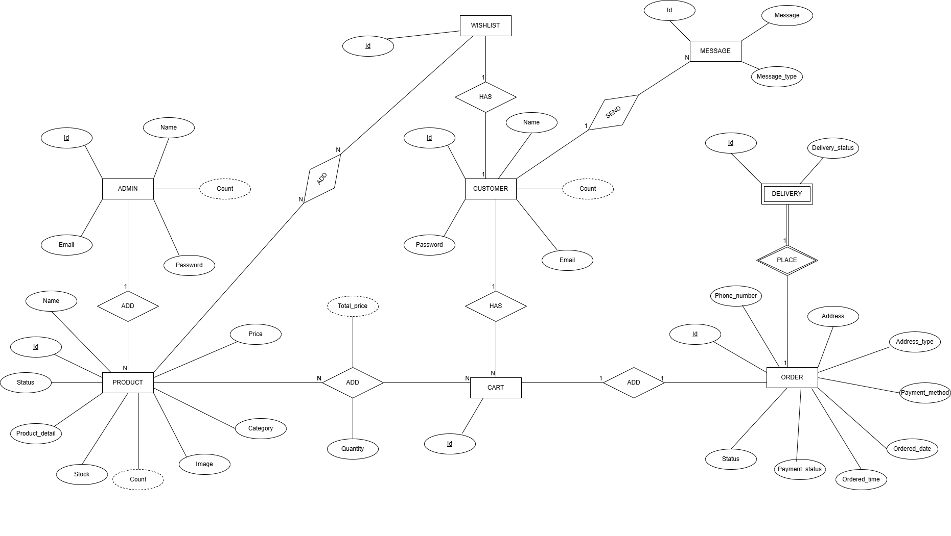
ER Diagram

Assumption:

- Customer needs to log the system in order to place the order.
- DELIVERY is necessary to place a ORDER and a ORDER can have only one DELIVERY and vice versa.

Tools Used:
- The Entity-Relationship (ER) diagram for this project was designed and drawn using Draw.io, an online diagramming tool. https://app.diagrams.net/ was selected for its ease of use, wide range of diagramming features, and support for ER modeling.

Relations Explanation

ADMIN - PRODUCT Relation
- One ADMIN can add many PRODUCTs and a PRODUCT can have only one ADMIN.

CUSTOMER-CART Relation
- One CUSTOMER can have many CARTs and a CART can have only one CUSTOMER.

CUSTOMER-WISHLIST Relation
- One CUSTOMER can have one WISHLISTs and a WISHLIST can have only one CUSTOMER.

CUSTOMER-MESSAGE Relation
- One CUSTOMER can send many MESSAGEs and a MESSAGE can have only one CUSTOMER.

PRODUCT-CART Relation
- One CART can add many PRODUCTs and a PRODUCT can have many PRODUCTs.

PRODUCT- WISHLIST Relation
- One WISHLIST can add many PRODUCTs and a PRODUCT can have many WISHLISTs.

CART -ORDER Relation
- One CART can add one ORDER and a ORDER can have only one CART.

ORDER- DELIVERY Relation
- ORDER is necessary to place a DELIVERY and a DELIVERY can have only one ORDER and vice versa
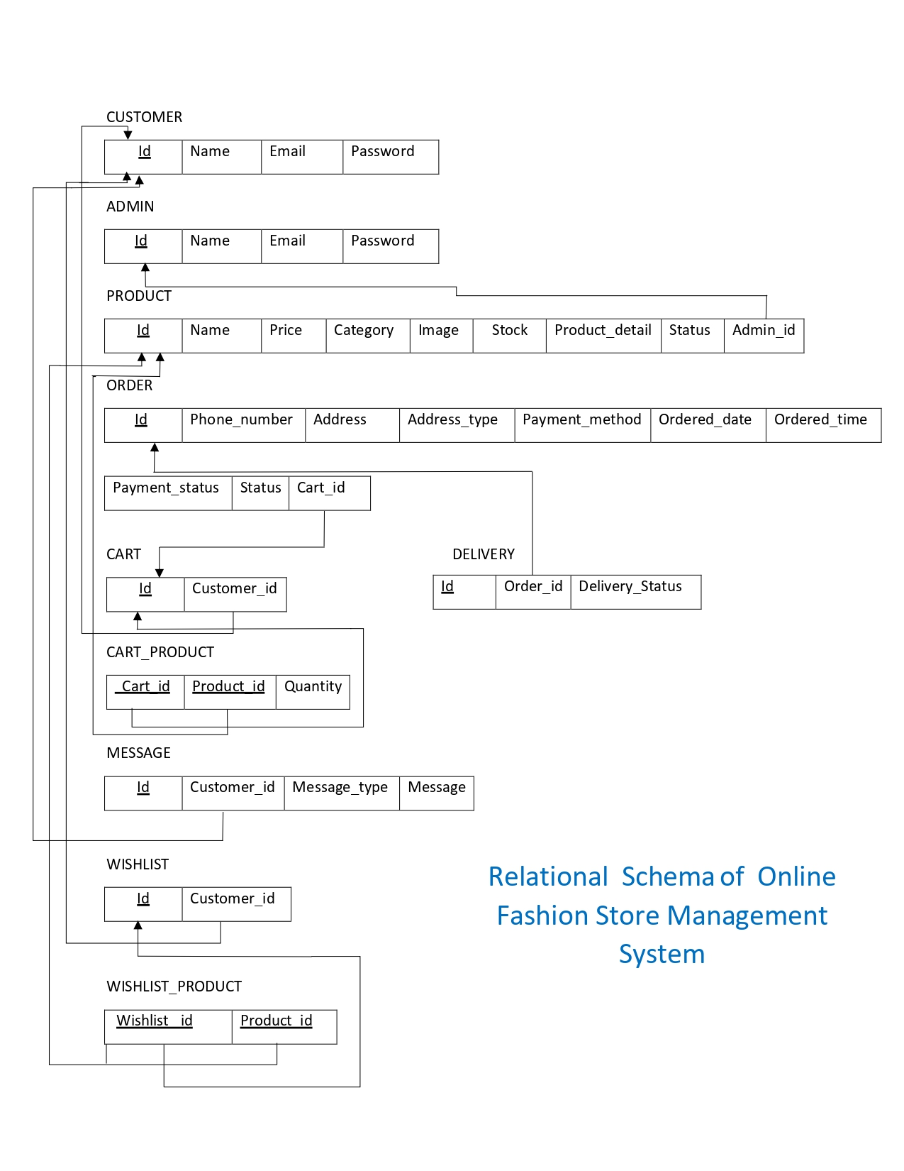
CREATION OF DATABASE

1. Start Apache and MySQL
- Opened XAMPP control panel.
- Clicked "Start" for Apache and MySQL.
2. Open phpMyAdmin
- In our browser, went to: http://localhost/phpmyadmin
3. Create Database
- Clicked "New" on the left side.
- Created a database name by SQL language (online_fashion_store_management_system).
CREATE DATABASE online_fashion_store_management_system;
4. Create Table
- We went Inside our database using SQL language.
USE online_fashion_store_management_system;
- Added Tables with fields (columns)
- CUSTOMER Table
CREATE TABLE CUSTOMER(
Id INT(15) AUTO_INCREMENT,
Name VARCHAR(100) NOT NULL,
Email VARCHAR(100) NOT NULL,
Password VARCHAR(10) NOT NULL,
PRIMARY KEY (Id),
UNIQUE (Email)
);

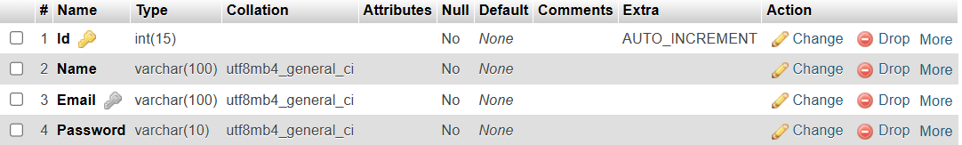
- ADMIN Table

CREATE TABLE ADMIN(
Id INT(15) AUTO_INCREMENT,
Name VARCHAR(100) NOT NULL,
Email VARCHAR(100) NOT NULL,
Password VARCHAR(10) NOT NULL,
PRIMARY KEY (Id),
UNIQUE (Email)
);

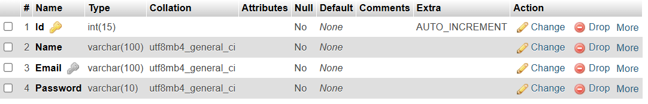

- PRODUCT Table

CREATE TABLE PRODUCT(
Id INT(15) AUTO_INCREMENT,
Name VARCHAR(100) NOT NULL,
Price DOUBLE(8,2) NOT NULL,
Category VARCHAR(50) ,
Image MEDIUMBLOB ,
Stock INT(6) DEFAULT 0,
Product_detail TEXT NOT NULL,
Status VARCHAR(50) NOT NULL,
Admin_id INT(15),
PRIMARY KEY (Id),
FOREIGN KEY (Admin_id) REFERENCES ADMIN (Id) ON DELETE SET NULL ON UPDATE CASCADE
);

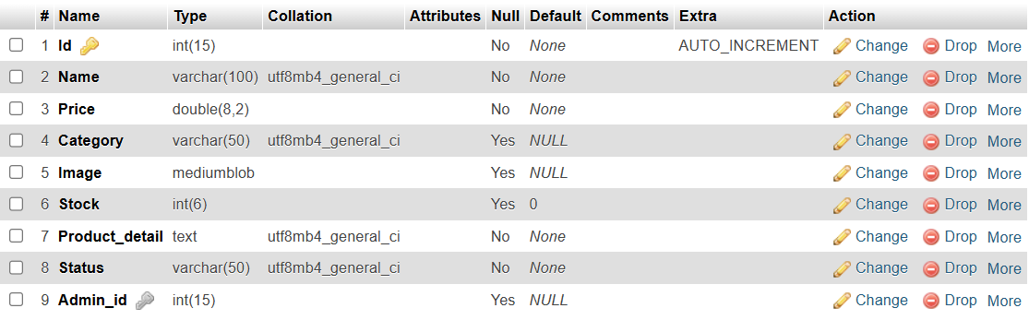
- CART Table

CREATE TABLE CART(
Id INT(15) AUTO_INCREMENT,
Customer_id INT(15),
PRIMARY KEY (Id),
FOREIGN KEY (Customer_id) REFERENCES CUSTOMER (Id) ON DELETE SET NULL ON UPDATE CASCADE
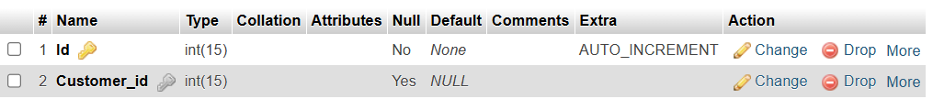
);

- CART_PRODUCT Table
CREATE TABLE CART_PRODUCT(
Cart_id INT(15) ,
Product_id INT(15),
Quantity INT(6) DEFAULT 0 ,
PRIMARY KEY (Cart_id, Product_id),
FOREIGN KEY (Cart_id) REFERENCES CART (Id) ON DELETE CASCADE ON UPDATE CASCADE,
FOREIGN KEY (Product_id) REFERENCES PRODUCT (Id) ON DELETE CASCADE ON UPDATE CASCADE
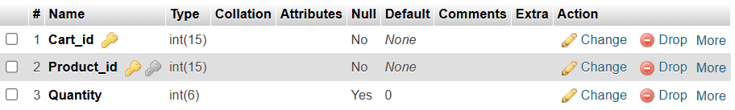
);
- WISHLIST Table

CREATE TABLE WISHLIST(
Id INT(15) AUTO_INCREMENT,
Customer_Id INT(15),
PRIMARY KEY (Id),
FOREIGN KEY (Customer_Id) REFERENCES CUSTOMER (Id) ON DELETE SET NULL ON UPDATE CASCADE
);
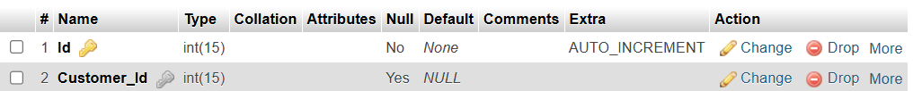

- WISHLIST_PRODUCT Table
CREATE TABLE WISHLIST_PRODUCT(
Wishlist_id INT(15),
Product_id INT(15),
PRIMARY KEY (Wishlist_id, Product_id),
FOREIGN KEY (Wishlist_id ) REFERENCES WISHLIST (Id) ON DELETE CASCADE ON UPDATE CASCADE,
FOREIGN KEY (Product_id) REFERENCES PRODUCT (Id) ON DELETE CASCADE ON UPDATE CASCADE
);
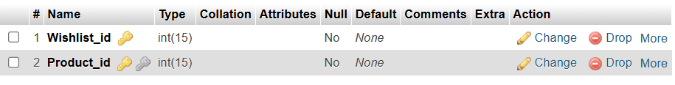

- MESSAGE Table
CREATE TABLE MESSAGE(
Id INT(15) AUTO_INCREMENT,
Customer_id INT(15),
Message_type VARCHAR(9) NOT NULL,
Message TEXT NOT NULL,
PRIMARY KEY (Id),
FOREIGN KEY (Customer_id) REFERENCES CUSTOMER (Id) ON DELETE SET NULL ON UPDATE CASCADE
);

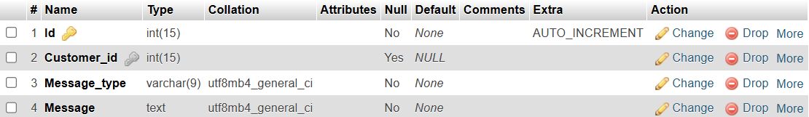

- ORDER_TABLE Table

CREATE TABLE ORDER_TABLE(
Id INT(15) AUTO_INCREMENT,
Phone_number VARCHAR(15) NOT NULL,
Address VARCHAR(100) NOT NULL,
Address_type VARCHAR(7) NOT NULL,
Payment_method VARCHAR(20) NOT NULL,
Ordered_date DATE NOT NULL ,
Ordered_time TIME NOT NULL ,
Payment_status VARCHAR(50) NOT NULL,
Status VARCHAR(50) NOT NULL,
Cart_id INT(15),
PRIMARY KEY (Id),
FOREIGN KEY (Cart_id) REFERENCES CART (Id) ON DELETE SET NULL ON UPDATE CASCADE
);
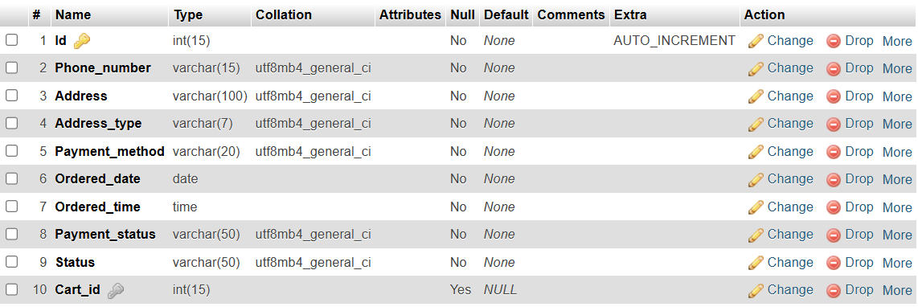
- DELIVERY Table

CREATE TABLE DELIVERY(
Id INT(10) AUTO_INCREMENT,
Order_id INT(15),
Delivery_status VARCHAR(50) NOT NULL,
PRIMARY KEY (Id), FOREIGN KEY (Order_id) REFERENCES ORDER_TABLE (Id) ON DELETE SET NULL ON UPDATE CASCADE
);
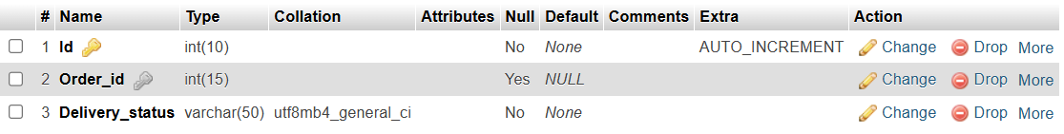

Assumptions
- Address_type of ORDER_TABLE should be only Home or Office.
- Payment_method of ORDER_TABLE should be only cash or card or online.
- Message_type of MESSAGE should be only Complaint or Normal.

- ALL TABLES
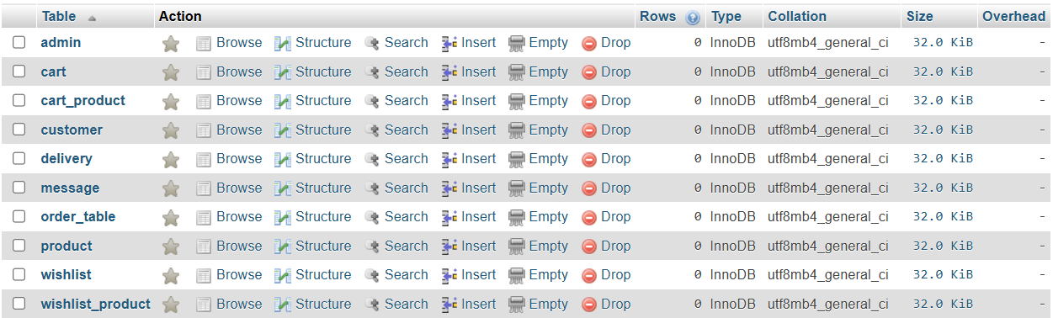

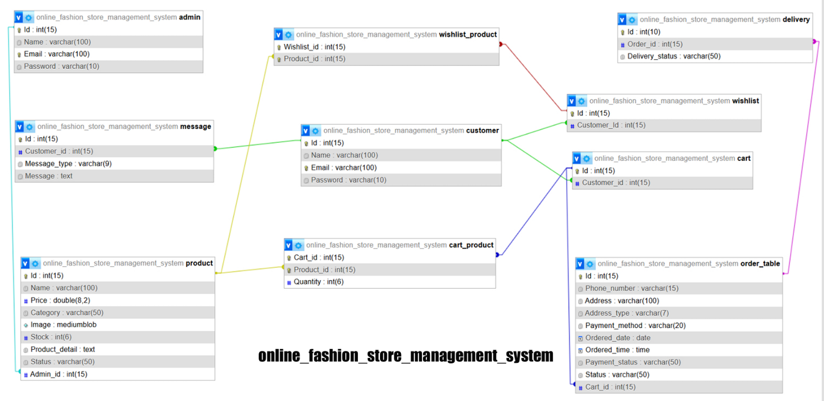
- TABLE DESIGN AND CONNECTIONS

TESTING PHASE

ADDING DUMMY DATA

- For customer table
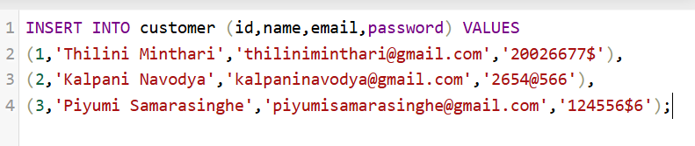
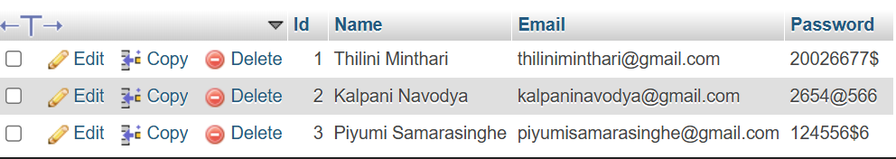

- For admin table
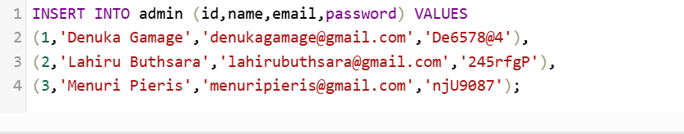
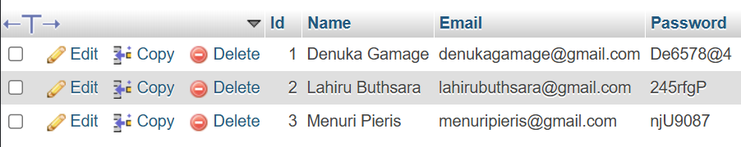
- For product table
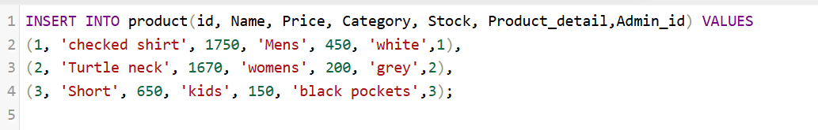
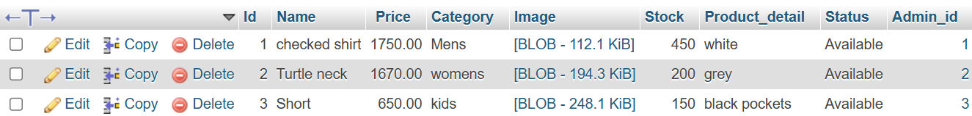

- For cart table
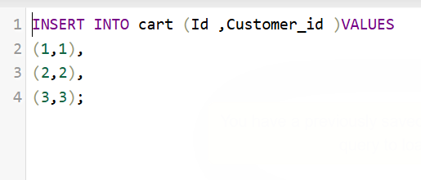
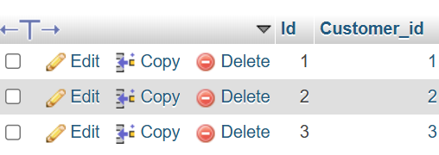

- For cart_product table
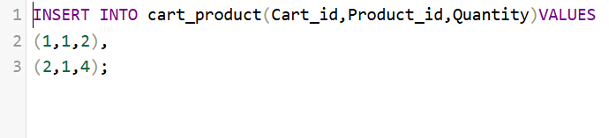
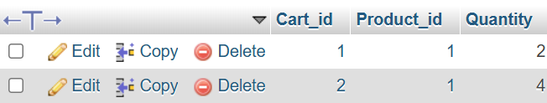

- For wishlist table
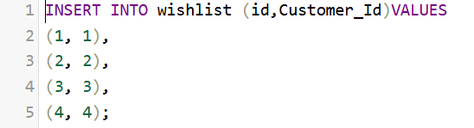
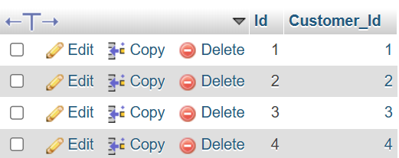

- For wishlist_product table
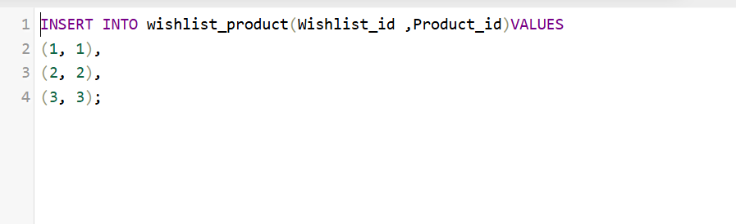
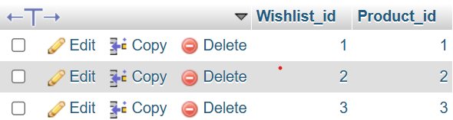

- For Message table
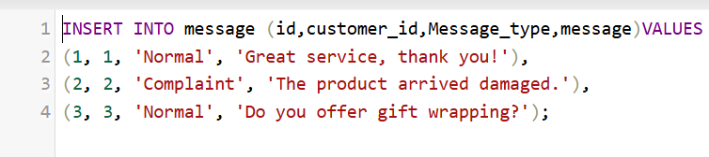
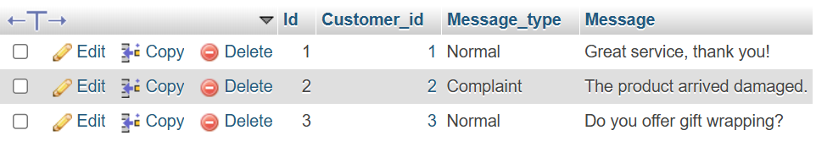

- For order_table table
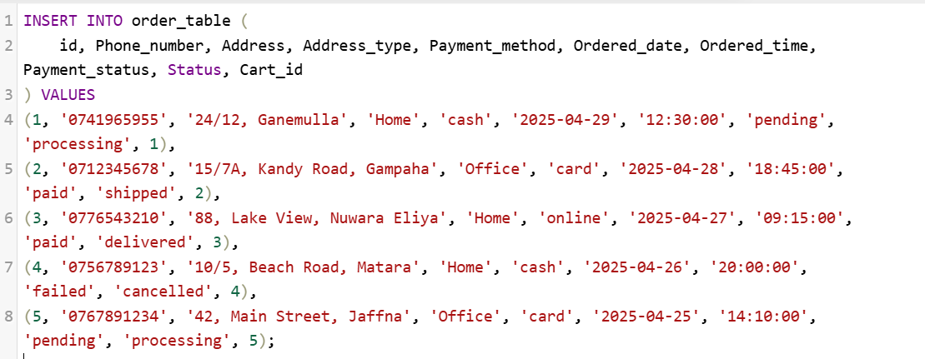
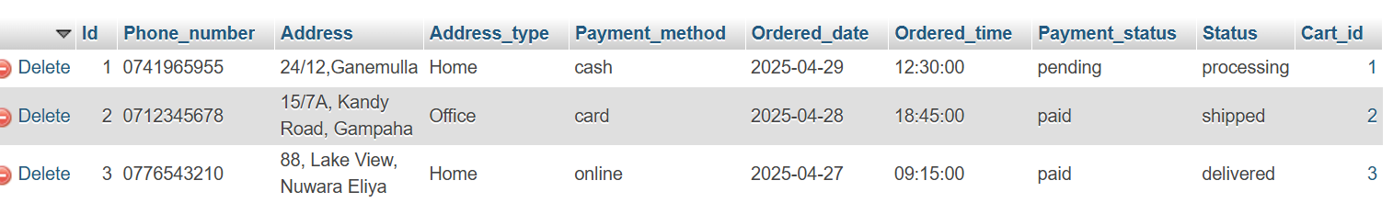

- For delivery table
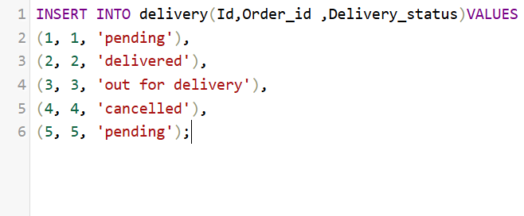
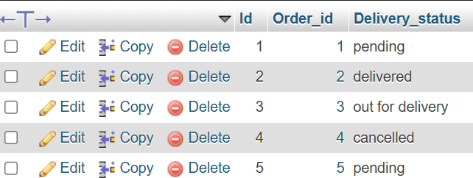

ALTERING DATA IN THE TABLES USING QUERIES
- Deleting an admin from the Admin table
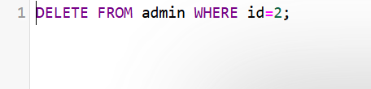
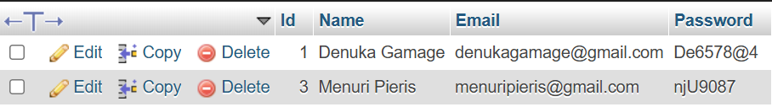
A record was deleted from the admin table, potentially affecting related entries in the product table.

Product table
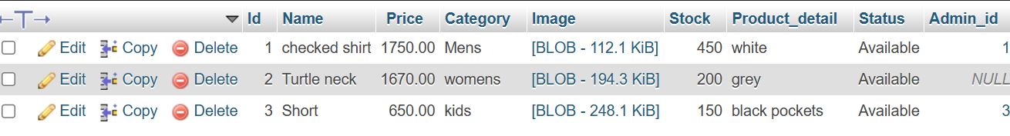
- Deleting a customer from the customer Table.
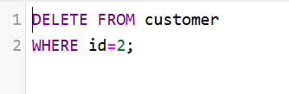
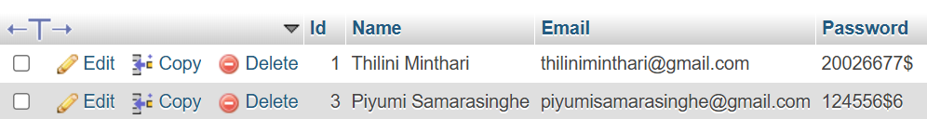
A record was deleted from the customer table, potentially affecting related entries in the cart, wishlist and message tables.
Cart table
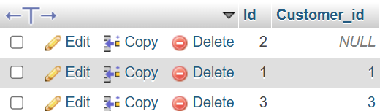
wishlist table
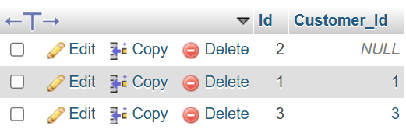
message table
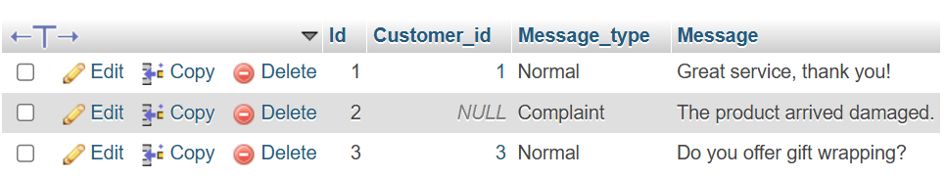
• Update the email of a customer in the database.
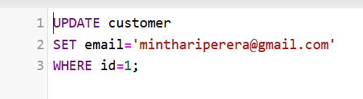

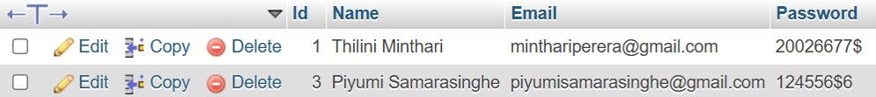
• Select Phone_number , Address, Ordered_date, Ordered_time, Delivery_status from the ordered_table and delivery tables.
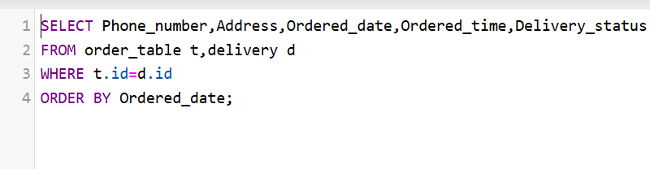
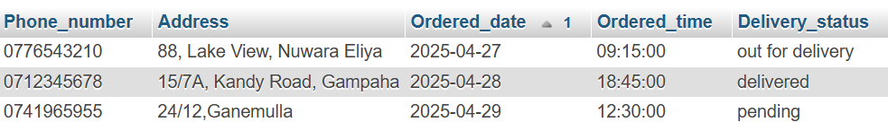

CONTRIBUTIONS

1. D. L. A. Thathsarani
- Contributed in creating the front end and back end of Admin Dashboard.
- Contributed in creating the front end and back end of the User Dashboard.

2. N .D. K. N. Sooriyasena
- Contributed in creating the front end and back end of Products pages(women, men, kids, watch-collection )
- Contributed in creating the front end and back end of order status.
- Assisted in designing the other pages.
- Created the relational schema for the project report.

3. N. A. S. Perera
- Contributed in creating the front end and back end of checkout page.
- Contributed in creating the front end and back end of About us page.
- Contributed in writing queries for the database and created the project report.

4. D. C. A. Gamage
- Designed Front End pages and backend of Home Page, Login, and Register including the Navigation bar, Footer.
- Assigned tasks to team members and managed their pull requests on GitHub.
- Assisted in developing Back End features for Checkout, Shopping Cart, Wishlist, Main Item, and Contact Us.

5. D. L. B. Wijesekara
- Add product details and contact us pages.
- Planning and Designing the ER Diagram and relational schema for Database.
- Planning the database format and designing the database with its tables
- Create Database details & ER Diagram pages for Project report.

6. H. G. G. De Zoysa
- Contributed in creating the front end and back end of Shopping Cart.
- Contributed in creating the front end and back end of Wishlist.

- The project's source code and documentation can be accessed via the GitHub repository:
  - https://github.com/dcagamage/Online-Fashion-Store-Management-System

-End of the Report-

